DataBase 1st Proposal Report



21500095 김시온

21500643 정선일

21600752 하재경

21700034 곽영혜

1. Motivation

: Music is the most intimate and easily accessible data for us. With the development of pop music, music data has become so vast that it is difficult to manage, and the types of data such as singers, songs, albums, genres are becoming more diverse. A systematic database system is necessary for developers to store, manage and utilize data. In addition, efficient data provision is essential for many of these users, with the number of domestic music users standing at 7.43 million. By building a systematic music database through this task, users and developers can use music data efficiently.

1. Goals

: Designs and develops a systematic music database system for users and developers who manage and provide music data.

From the developer's perspective, the connectivity and relationships between tables help developers easily access data and use concise query.

From the user's perspective, the system is quickly and efficiently available when listening to music, searching for music-related information, and checking information.

1. Expected outcomes

: We expect end-product to be user using site Melon or Jenie and developer. Our database contains user’ personal information (such as age, name, gender etc.), solo singer or group singer’s information (such as name, debut year etc.), and writer’s information (such as name, gender etc.). we are expecting to have about 12 tables. We are planning to develop. The platform we will use include Java and MySQL.

1. Broad impact

: Users can search for and use the music they want by making music data easier to use. The system also allows developers to recommend songs by genre, age and time to users. This makes it easy for users to listen to the music they want, and effectively advertise to the people who make the music.

1. DB Schema

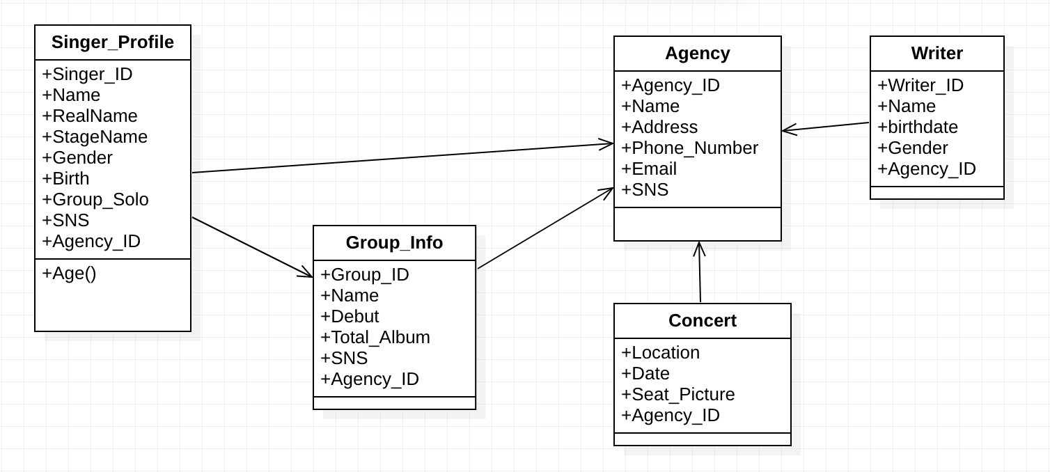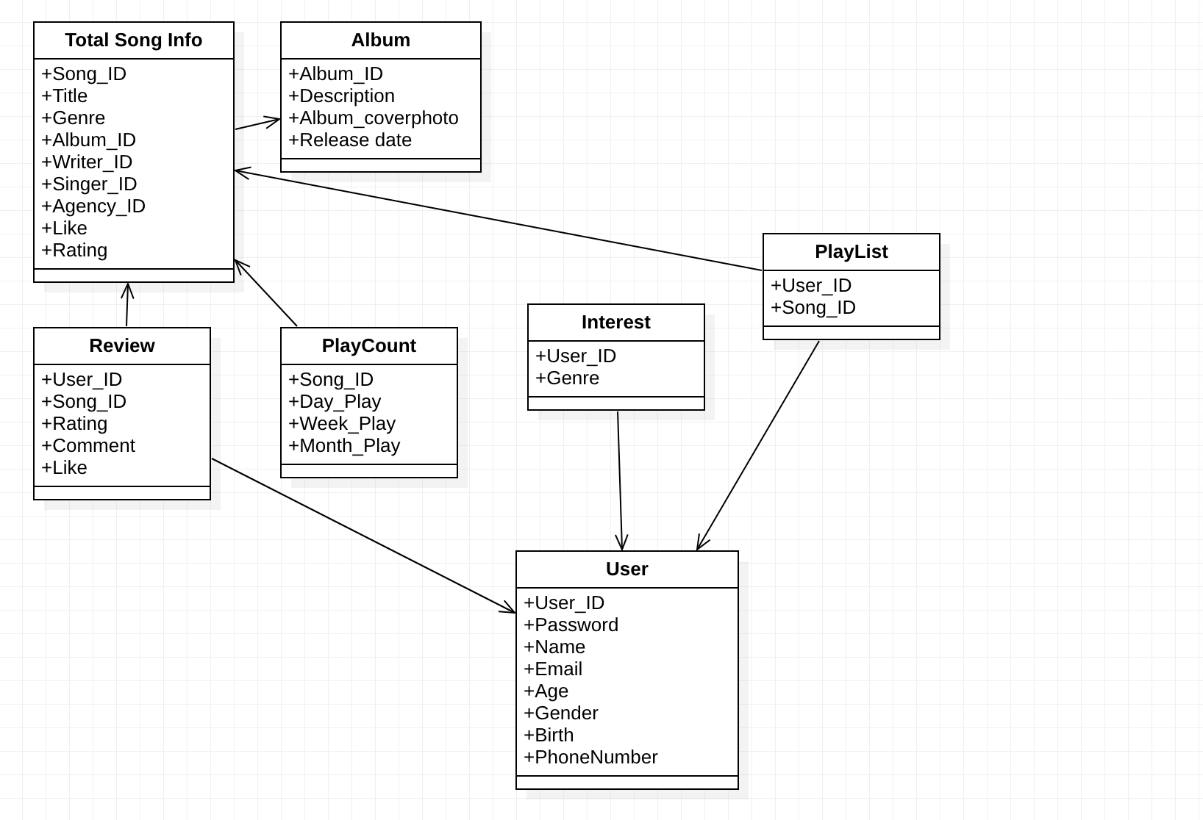

1. Timeline

